12、Seek light

**Follow the steps to splice the building blocks ：**

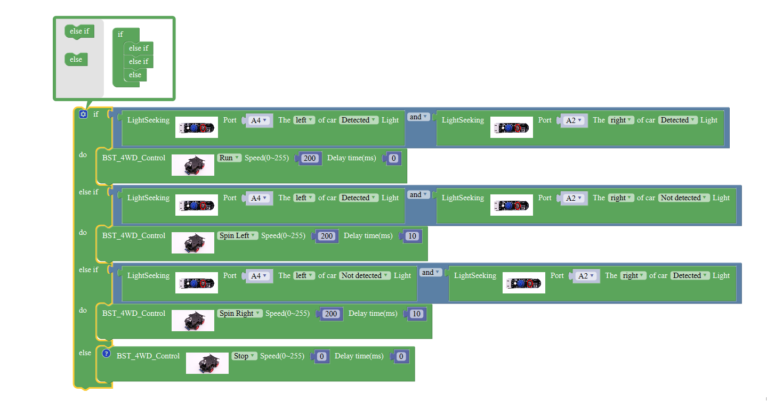

**1、Experimental building blocks :**

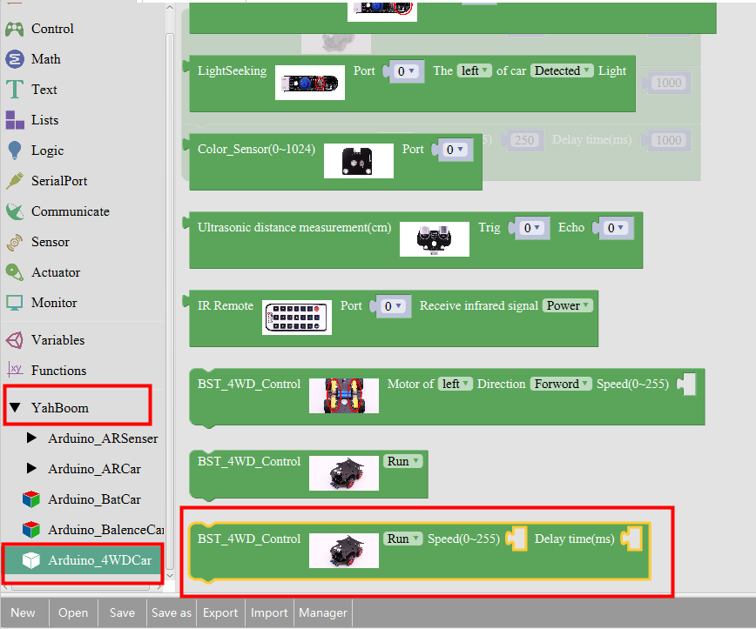

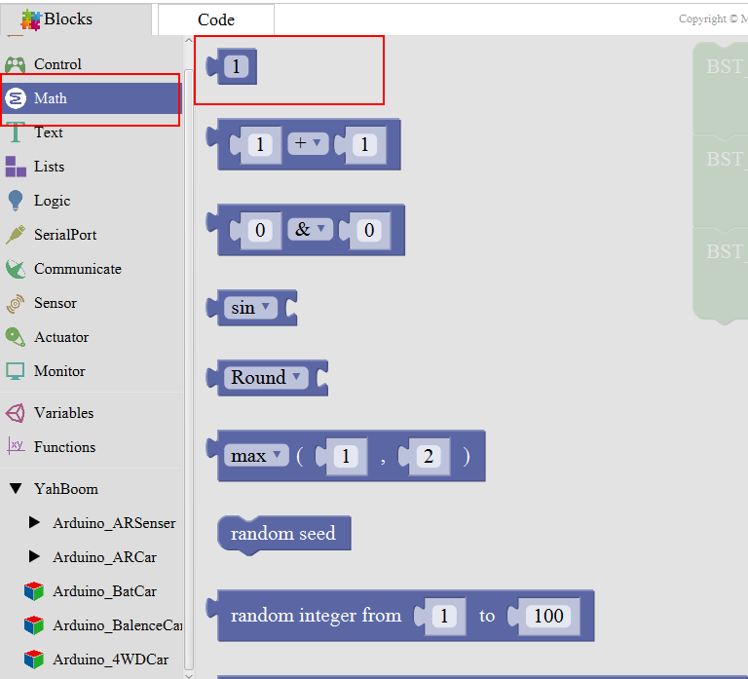

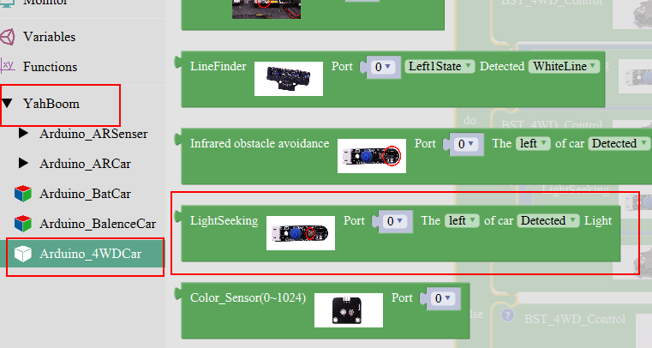

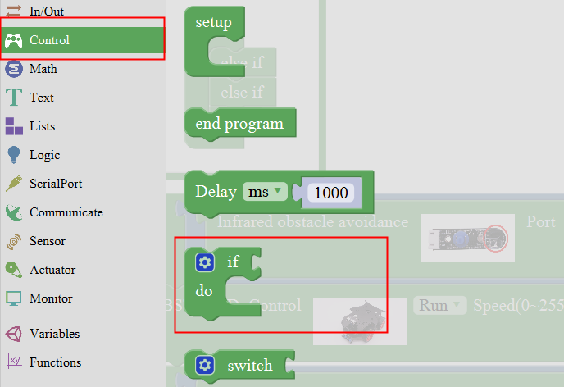

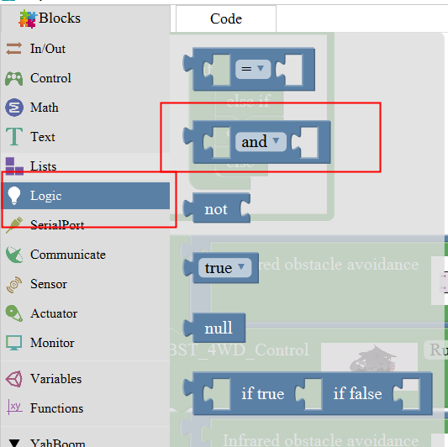

Note:

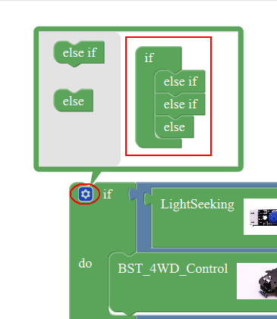

**2、Experimental verification：**

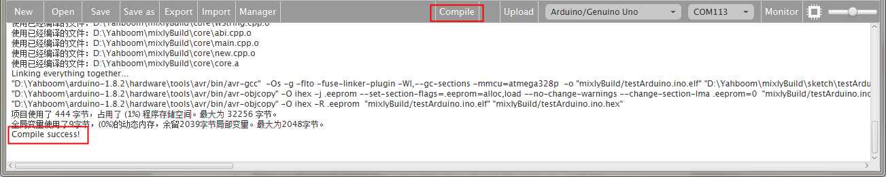

a、After splicing, select the compile button above the picture, wait for the completion of the compiler, the following box will prompt the compiler successfully, if prompt the compile failure is the problem of building block splicing.

b、After compiled , select **Arduino/Genuino Uno** follow the picture,

selects the serial number of the corresponding board.

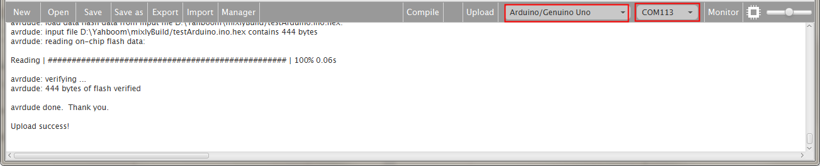

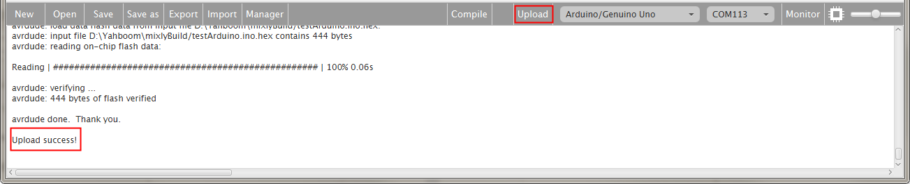

c、After configured,select the upload button above the picture, wait for the following box prompt the upload successfully. Debugging search light sensor, when exposure to the light source, the light source light is off, no radiation lit, and then power on, the car on the open ground, with a flashlight to find the light module on the left and right sides, to see whether the car with light walking.